Referral Form
Pregnancy Testing & Ultrasound
- Free, confidential pregnancy testing, STD testing and treatment, first trimester limited obstetric ultrasound
Pregnancy Loss Support
- Support for those who have experienced miscarriage or stillbirth
- Help & Healing for those with regret from an abortion decision
Parent Resources
- Moms’ Coaching, Men’s Coaching, Couples’ Coaching, Mothers’ Club, Family Store
Healthy Sexual Boundaries Education
- Teaching the positive option of abstinence before marriage through presentations or individual discussion.

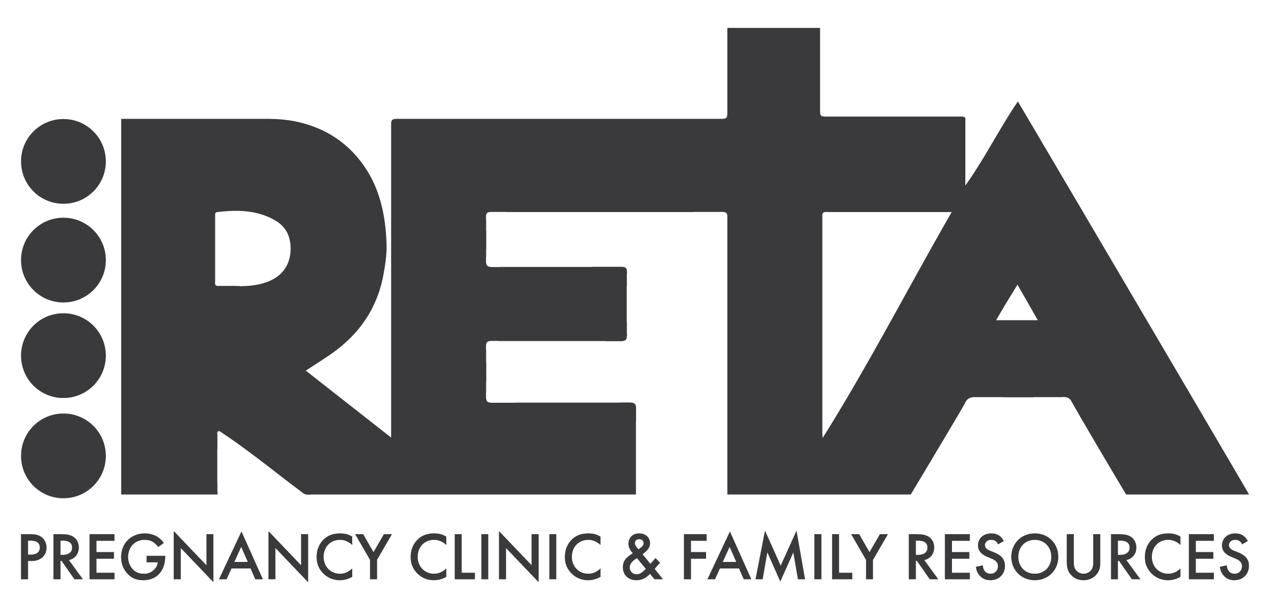
300 West High St.
Elkhart, IN 46516
(574) 522-3888
Fax (574) 293-5368
retaforlife.com

Referring Organization
Person making referral: __________________________________________________ Date: ____________________
Organization: __________________________________________________________________________________________________
Address: __________________________________________________________________________________________________
Phone Number: __________________________________ Fax Number:_________________________________
Client Information
Name: _____________________________________________________ Date of Birth:________________________
Address: ___________________________________________________________________________________________
Phone Number: _____________________________ Email: ______________________________________________
Referral For: ☐Medical Services (Pregnancy testing, STD testing, Ultrasound)
      - Females: First Day of Last Period: ______________________
☐Parenting Resources/Coaching ☐Healthy Sexual Boundaries Education
☐Pregnancy Loss Support ☐Abortion Recovery Support
☐Other: ________________________________

Client Signature: _____________________________________________ Date: _____________________

-------------------------------------------------------RETA Staff Use Only-----------------------------------------------------------------

Date referral received: _____________________ Person contacting client: ____________________________________
Able to contact? Yes No Appointment Made? Yes No

